Variables and Data Types in Java->

Variable is a name of memory location. There are three types of variables in java:

1. Local->

Which is declares in the method.

1. Instance->

A variable which is declared inside the class but outside the method .it’s not define static.

1. Static->

A variable that is declared as static is called static variable

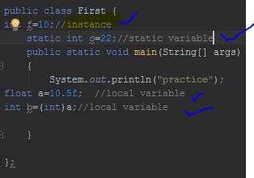

There are two types of data types in java: primitive and non-primitive.

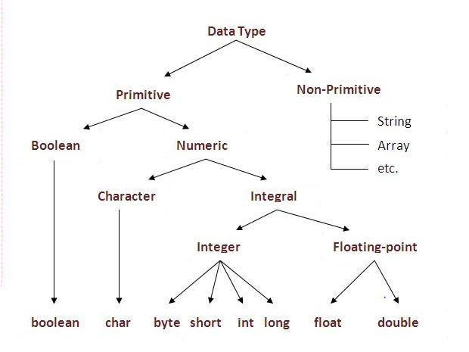

Size chart of data type variable->

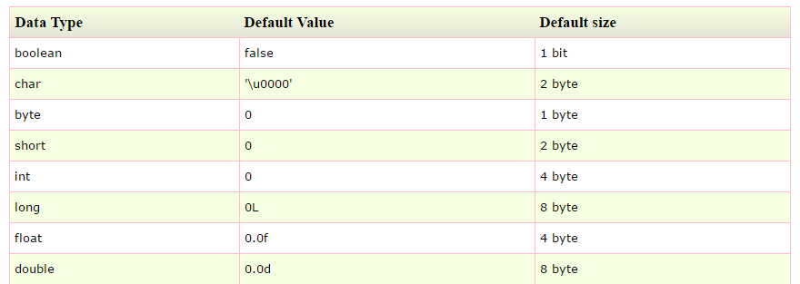

Oprators->

**Operator** in java is a symbol that is used to perform operations. For example: +, -, *, / etc.

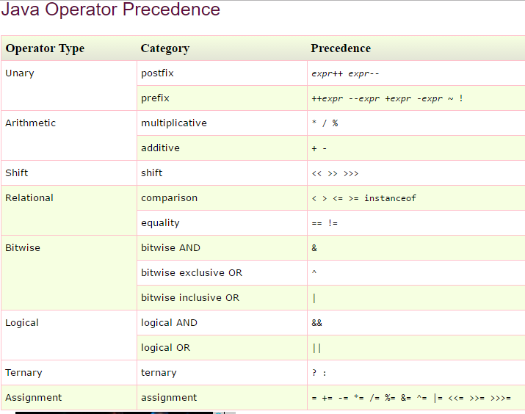

Types casting->

To change a data type of any variable.

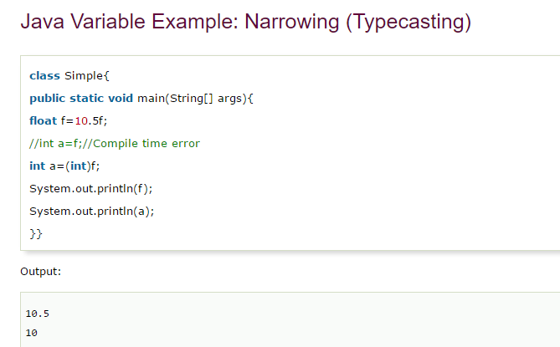

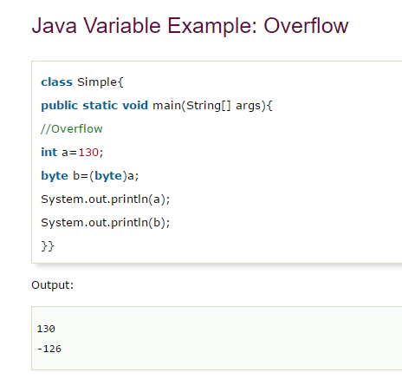

Java uses Unicode instead of ascii because it contains most of words written.